

Upcoming Events…

Dec. 1st: Papa John’s Night

Dec. 7th: Early Release, Students Dismiss @ 12:20

Dec. 8th: PTA Meeting & Razz-a-Tazz Chorus performs in the cafeteria @ 6:30 p.m. Chorus students must report to Mr. Simmon’s room at 6:15 p.m.

**What Are We Working On…**

**Reading: *Turn Homeward Hannalee* (RL2, RL3, RL4, RI4)**

**Language Arts: Comma Usage (L2)**

**Writing: Informational (W1-4)**

**Math: Compares Decimals to the Thousandths (NBT3)**

**Science: Genetics (S5L2)**

**Social Studies – America at the Turn of the Century (SS5H3)**



**5th Grade Holiday Party**

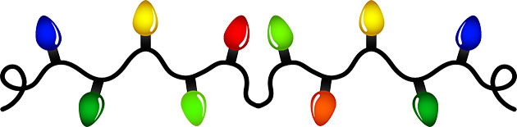

**This year’s 5th grade holiday party will be on Monday, December 19th from 8:30-11:30 a.m. The 5th grade teachers have planned a grade level rotating craft day. We are asking that each child bring in $5.00 towards the expense of these crafts. If you would like to volunteer in your child’s homeroom, please contact their teacher. Thank you for your involvement in celebrating the holidays with us.**

**Please don’t forget to complete the parent survey and let us know how we are doing! Below is the link. Thank you.**

[**http://apps.gadoe.org/schoolclimate/parents.nsf/survey.xsp**](http://apps.gadoe.org/schoolclimate/parents.nsf/survey.xsp)

**SCHOOL ATTENDANCE is essential to academic success, but too often students, parents, and schools don’t realize how quickly absences, whether excused or unexcused, can add up to academic trouble.**

**Every school day counts, and everyone can make a difference!**

**So you want to volunteer?**

***In order to volunteer in your child’s class or chaperone students on a field trip, you must watch the parent volunteer video:***

[**http://www.paulding.k12.ga.us/Page/825**](http://www.paulding.k12.ga.us/Page/825)

**Technology**

**Check out NITROTYPE a great website for your child to practice his/her typing skills**

[www.nitrotype.com](http://www.nitrotype.com)

**Check out Quizlet Vocab. Unit 7 Practice**

<https://quizlet.com/3180886/vocabulary-workshop-level-blue-unit-7-flash-cards/>

**Upcoming Assessments…**

**Reading: Compare and Contrast Characters SFA**

**Math: Rounding Decimals SFA, Comparing Decimals Quiz**